“Київський фаховий коледж зв’язку”

Циклова комісія комп’ютерної та програмної інженерії

**ЗВІТ ПО ВИКОНАННЮ**

**ЛАБОРАТОРНОЇ РОБОТИ №2**  
з дисципліни: «Операційні системи»  
Тема: “Знайомство з інтерфейсом та можливостями ОС Linux”

Виконали студенти

групи БІКС-13

Команда JRSY: Андрущик П.С   
Бурбан Д.Ю.  
Перевірив викладач

Сушанова В.С.

Київ 2023

**Мета роботи (готувала матеріал студентка Андрущик Поліна)**  
1.Familiarity with Linux OS interfaces.  
2. Acquiring practical skills of working in Linux OS and mobile OS environments - their graphical shell, logging in and out of the system, familiarization with the structure of the desktop, learning the basic actions and settings when working in the system.  
**Завдання для попередньої підготовки (готувала матеріал студентка Андрущик Поліна)**  
Read the short theoretical information for the laboratory work and make a small dictionary of basic English terms for the assignment of commands and their parameters.

|  |  |
| --- | --- |
| **Термін англійською** | **Термін українською** |
| The command line interface (CLI) | Інтерфейс командного рядка (CLI) |
| Application Programming Interface (API) | Інтерфейс прикладного програмування (API) |
| Central processing units (CPUs) | Центральні процесори (CPU) |
| Server Applications | Серверні програми |
| Desktop Applications | Програми робочого столу |

**Дайте визначення наступним поняттям (готувала матеріал студентка Андрущик Поліна)**  
  
**CLI Mode (Command-Line Interface)** is a user interface mode where interaction with the computer occurs through commands entered from the keyboard.

**Graphical User Interface-based Terminal (GUI Terminal)** is a program that provides the user with a graphical interface for interacting with the command line of the operating system.

**Virtual Terminal** is software that emulates the operation of a physical POS terminal. It allows online payment for goods and services without the need for specialized hardware.

**Основні позиції ходу роботи (готував матеріал студент Бурбан Данило)**  
**1.** **The structure of the workspace**

**1.1.** **Ran Linux with a Debian shell**

Applications tab

- Places tab

- System menu

- Activities overview navigation space

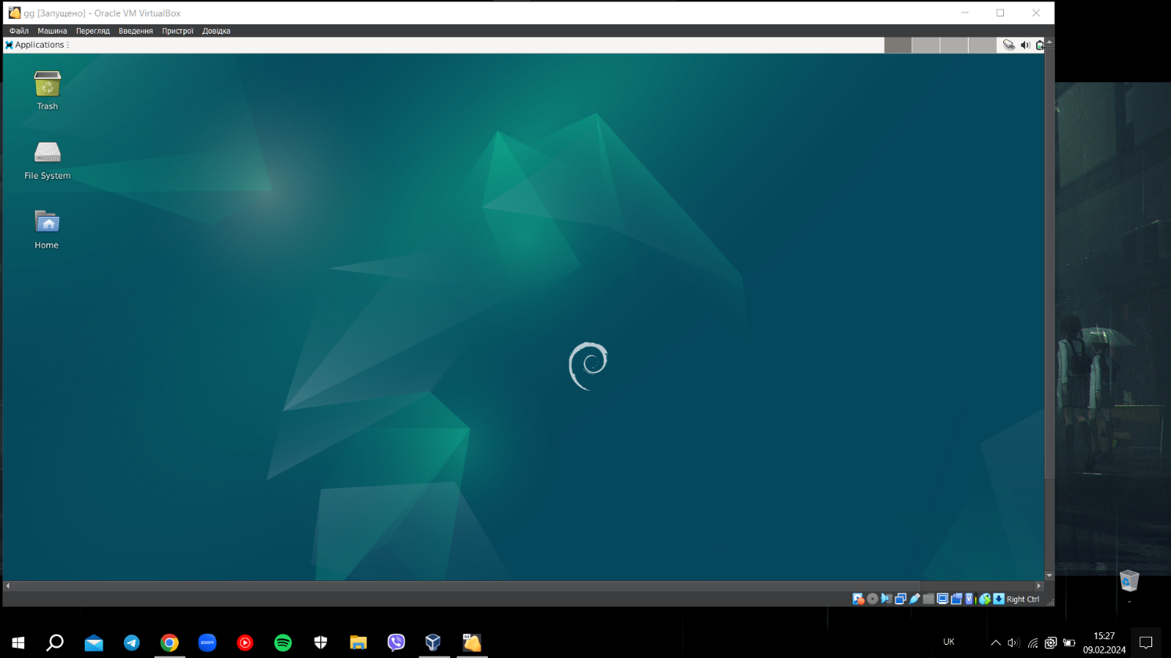

1.2.

1. Launch programs through the quick launch bar

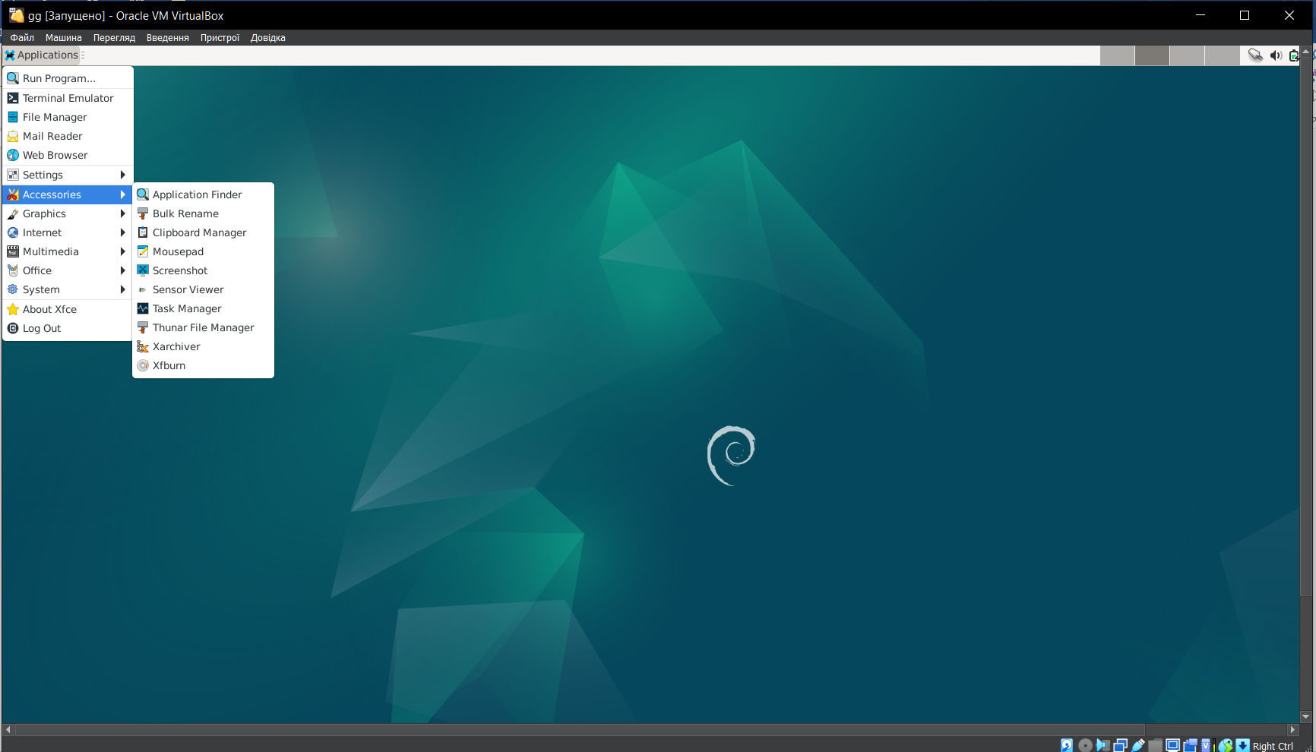

2. Launch programs via the launcher widget

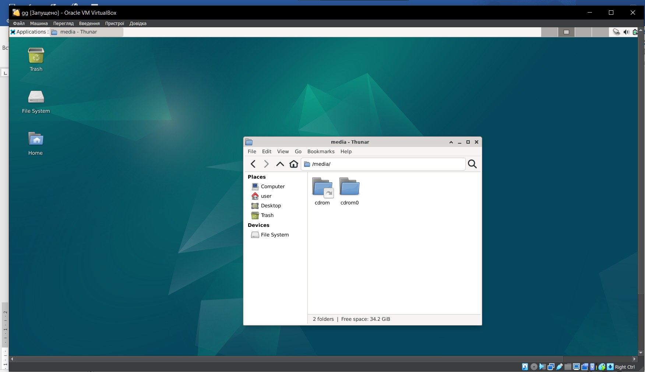

3. Launching programs through the global menu

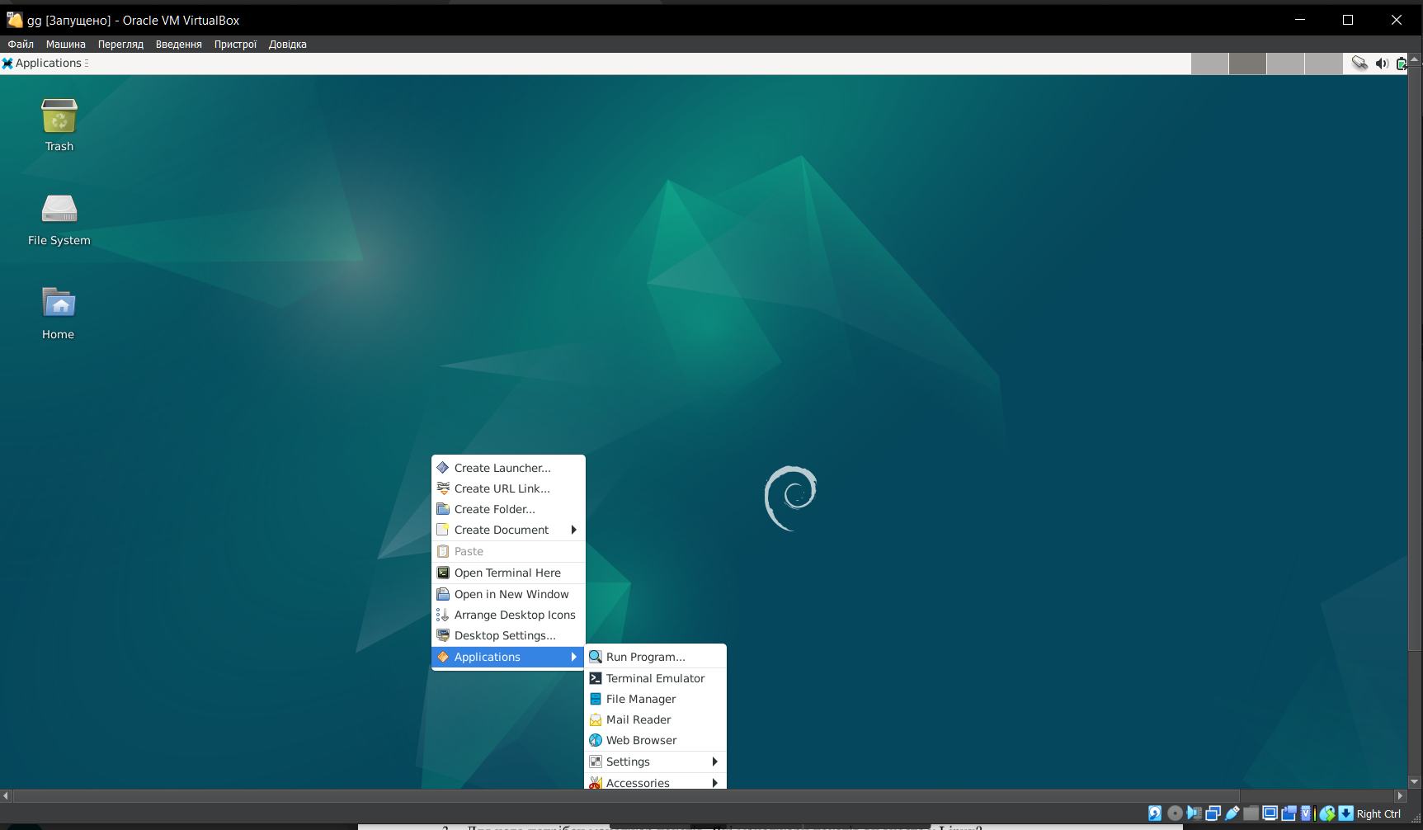

4. Launch programs through menu search

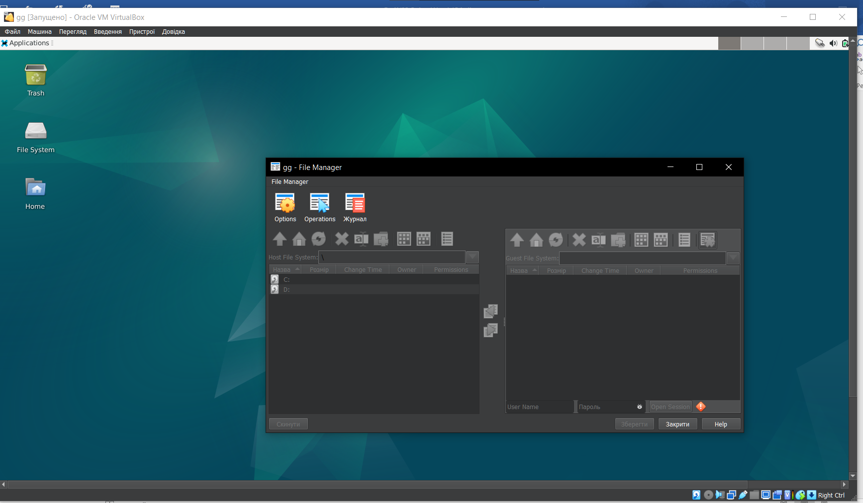

1.3.

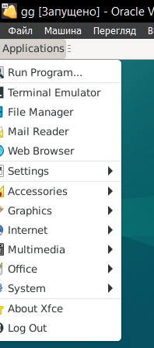 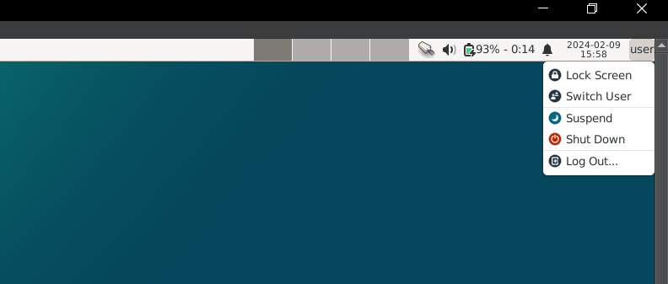

2.

2.1. **Опишіть головне меню вашої мобільної ОС, який графічний інтерфейс вона використовує?**

The main menu of the Android screen, which contains specific icons that perform various functions. Widgets, folders, wallpapers, and, as mentioned earlier, icons.

2.2. **Опишіть меню налаштувань компонентів мобільного телефону.**

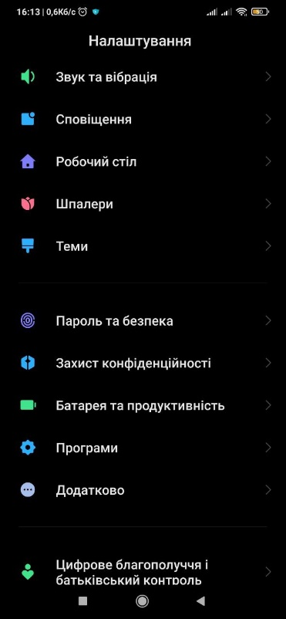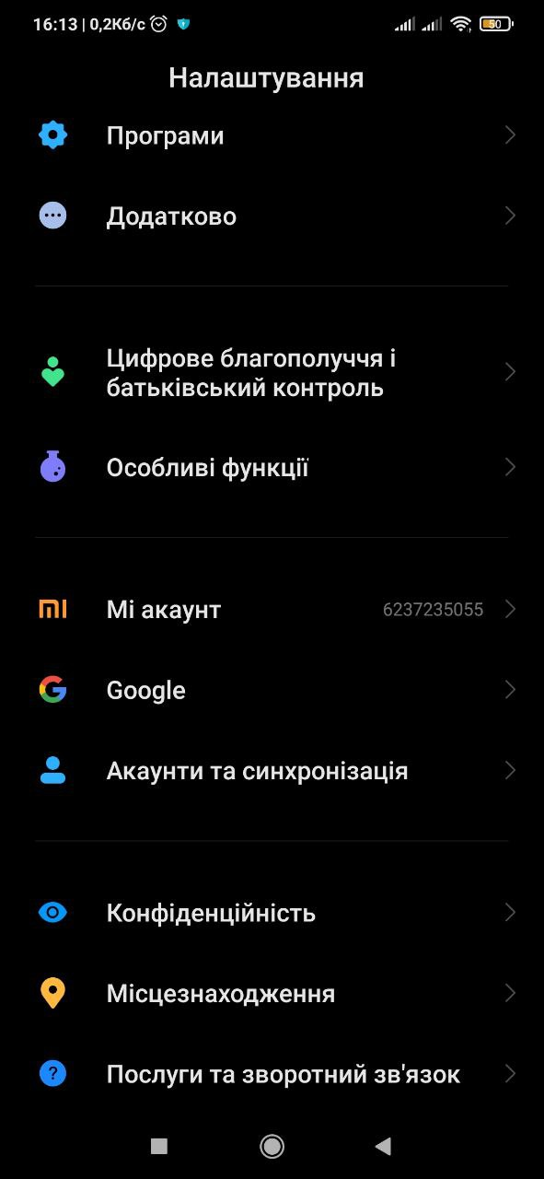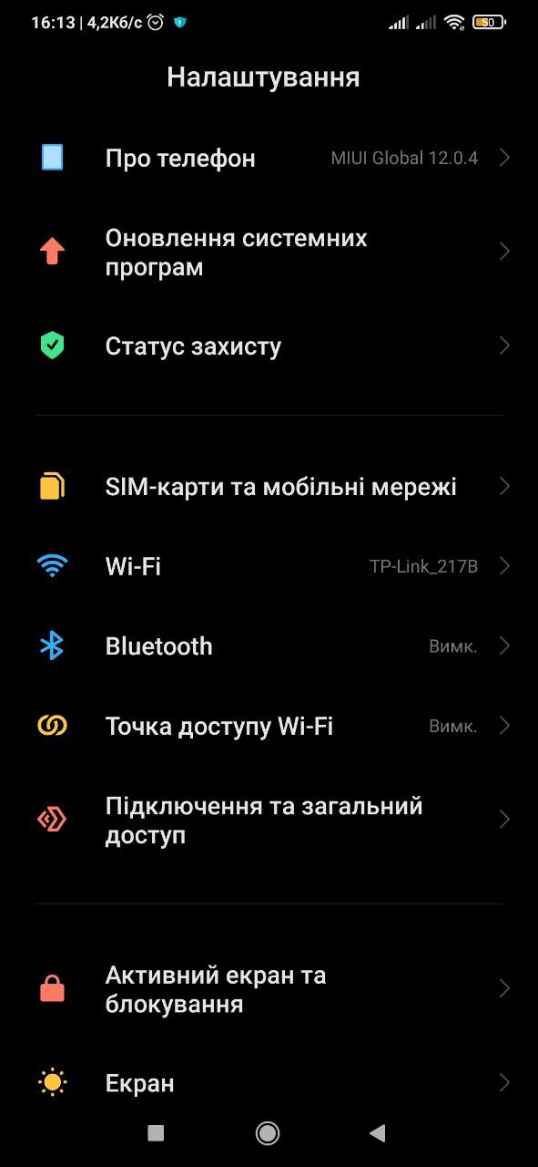

2.3**. Використання комбінацій клавіш для виконання спеціальних дій.**

Turn on/off the screen:

Take a screenshot:

Enter recovery mode:

Turn on/off sound:

Switch to vibration mode:

Open Google Assistant:

2.4. **Вхід у систему та завершення роботи пристрою. Особливості налаштувань живлення батареї.**

Login using unlocking (either PIN or pattern lock).

To shut down, press the power button and tap on the "Power off" window.

Battery features:

Power-saving mode:

Battery optimization:

Emergency power-saving mode:  
  
**Відповіді на контрольні запитання (готував матеріал Бурбан Данило)  
1. Наведіть приклади серверних додатків Linux для сервера баз даних, серверів розсилки повідомлень та файлообмінників.  
Сервери баз даних:  
MySQL:** A popular open source relational database management system (RDBMS).  
**PostgreSQL:** Another powerful open source RDBMS that offers advanced features and flexibility.  
**MariaDB**: Compatible with a fork of MySQL that offers increased performance and scalability.  
**MongoDB:** A NoSQL database used for unstructured documents and data.

**Mailing servers reports:  
Postfix:** A popular open source SMTP server used to send and create emails. **Exim:** Another powerful open source SMTP server that offers flexibility and customization. **Dovecot:** An IMAP/POP3 server used to access email with clients. **Sendmail:** SMTP server used to send emails.

**File sharers:  
Samba:** A protocol that allows file and printer sharing between Windows and Linux systems. **NFS:** A network file system used to share files and folders over a network. **FTP:** A file transfer protocol used to upload and download files from a server. **WebDAV:** Web-based Distributed Authoring and Versioning, used for file sharing and editing via a web interface.

**2. Порівняйте оболонки Bourne, C, Bourne Again (Bash), the tcsh, Korn shell (Ksh) та zsh.**

|  |  |  |
| --- | --- | --- |
| **Оболонка** | **Рік випуску** | **Особливості** |
| Bourne shell (sh) | 1977 | A simple, native Unix shell. |
| C shell (csh) | 1978 | Improved C-like syntax. |
| Bourne Again shell (Bash) | 1989 | A powerful shell with advanced capabilities and built-in functions. |
| tcsh | 1983 | Improved C shell with support for command history and line editing |
| Korn shell (ksh) | 1985 | A powerful shell with improved syntax and built-in functions. |
| zsh | 1990 | A powerful skin with advanced features, autocompletion and design themes. |

**3. Для чого потрібен менеджер пакетів. Які менеджери пакетів ви знаєте у Linux?**A package manager is software **used to simplify the process of installing, updating, and removing software on Linux distributions.  
Features:**  
**-Search:** Package managers allow you to search for packages by name, description, or functionality.  
**-Installation:** Package managers automatically download and install packages and resolve dependencies between packages.  
**-Updates:** Package managers allow you to update packages to the latest versions as well as track available updates.  
**-Uninstallation:** Package managers allow you to remove packages as well as clean up the garbage behind them.

**4. Які засоби безпеки використовуються в Linux?  
Permissions:** Linux uses a system of permissions to control who has access to files and directories. Each file and directory has its own rights for owner, group and other users.  
**Firewall:** In Linux, you can configure a firewall to filter network traffic and protect the system from dangerous connections. iptables and more modern nftables are firewall configuration tools.  
**SELinux (Security-Enhanced Linux):** SELinux is an access control system that allows you to define security rules for processes and system resources. It provides an additional level of protection.  
**AppArmor and GRSecurity:** These systems provide additional access control mechanisms, limiting the authority of applications and processes.  
**Updates:** Regular installation of updates and patches for the Linux kernel and software is an important element of security.  
**Auditing (Audit Framework):** Linux has an auditing framework that allows you to log security events such as login attempts, file changes, etc.  
**SSH (Secure Shell):** Secure remote access to the system uses the SSH protocol, which provides encryption and authentication.  
**Password management and password policies:** Establishing strong passwords, password policies, and other means to ensure authentication security.

**5. Чому використання віртуалізації зараз стало таким актуальним?**The use of virtualization has become relevant due to the ability to efficiently use resources, facilitate infrastructure management, and provide flexibility in deployment and scaling.

**6. Як ви розумієте поняття контейнеризації?**Containerization is a technology for packaging and executing applications, along with all their dependencies and configuration, in an isolated environment that simplifies application deployment and management.

**7. Які переваги/недоліки використання програмного забезпечення з відкритим кодом?  
Advantages:  
-Free:** Most open source software is free to use and distribute.  
**-Transparency:** The code of open source programs is available to everyone, allowing it to be studied, modified and improved.  
**-Security:** Thanks to open source, vulnerabilities can be easily found and fixed.  
**-Community:** Open source software has an active community of users and developers who provide support and assistance.

**Disadvantages:  
-Support:** Official support from developers is not always available.  
**-Functionality:** Open source software may have less functionality than commercial counterparts.  
**-Complexity:** Some open source programs can be difficult to set up and use.  
**-Licensing:** Different licenses may have different restrictions on the use and modification of the code.

**8. ***Скільки активних віртуальних консолей (терміналів) може бути у процесі роботи Linux по замовчуванню. Як їх викликати та між ними перемикатися? Наведіть приклади?  
By default, 6 virtual consoles are available in Linux.** You can switch between them as follows:  
Ctrl + Alt + F1: First virtual terminal.  
Ctrl + Alt + F2: Second virtual terminal, and so on until Ctrl + Alt + F6.

**Example of switching:**Ctrl + Alt + F2 is used to switch from the first console to the second.  
To return to the first console, use Ctrl + Alt + F1.

**9.***Яка віртуальна консоль (термінал) виконує функцію графічної оболонки?**In Linux, the virtual console, which acts as a graphical shell, is mainly located in the seventh virtual terminal and can be called by pressing Ctrl + Alt + F7. This terminal runs a graphical interface (such as X Window System or Wayland) that allows the user to use graphical programs and environments such as GNOME, KDE, or others.

**10. ***Чи можлива реєстрація в системі Linux декілька разів під одним і тим же системним ім’ям? Які переваги це може надати?**In Linux, it is possible to have multiple accounts with the same username but with different unique user identifiers (UIDs), and the system identifies them by this identifier, not by the name itself.

The ability to register multiple times under the same username with different UIDs **allows you to provide separate access rights and configurations for different virtual or restricted environments.**

**Conclusion: We installed the Debian shell, checked how the system works, familiarized ourselves with the Linux interface and its general functions. We gave a description of OS mobile. Answered the questions. Fixed the material.**